**1)**

**Peterson Algorithm:**

#include <stdio.h>

#include <stdlib.h>

#include <unistd.h>

#include <time.h>

#include <sys/types.h>

#include <sys/ipc.h>

#include <sys/shm.h>

#include <sys/wait.h> // Include this for wait()

#include <stdbool.h>

#define BSIZE 8 // Buffer size

#define PWT 2 // Producer wait time limit

#define CWT 10 // Consumer wait time limit

#define RT 10 // Program run-time in seconds

int shmid1, shmid2, shmid3, shmid4;

key_t k1 = 5491, k2 = 5812, k3 = 4327, k4 = 3213;

bool* SHM1;

int* SHM2;

int* SHM3;

int myrand(int n) {

return (rand() % n + 1);

}

int main() {

// Create shared memory segments

shmid1 = shmget(k1, sizeof(bool) * 2, IPC_CREAT | 0660); // flag

shmid2 = shmget(k2, sizeof(int) * 1, IPC_CREAT | 0660); // turn

shmid3 = shmget(k3, sizeof(int) * BSIZE, IPC_CREAT | 0660); // buffer

shmid4 = shmget(k4, sizeof(int) * 1, IPC_CREAT | 0660); // state

if (shmid1 < 0 || shmid2 < 0 || shmid3 < 0 || shmid4 < 0) {

perror("Main shmget error");

exit(1);

}

SHM3 = (int*)shmat(shmid3, NULL, 0);

int ix = 0;

while (ix < BSIZE) // Initializing buffer

SHM3[ix++] = 0;

int* state = (int*)shmat(shmid4, NULL, 0);

*state = 1;

int wait_time;

int i = 0; // Consumer

int j = 1; // Producer

if (fork() == 0) { // Producer code

SHM1 = (bool*)shmat(shmid1, NULL, 0);

SHM2 = (int*)shmat(shmid2, NULL, 0);

SHM3 = (int*)shmat(shmid3, NULL, 0);

if (SHM1 == (bool*)-1 || SHM2 == (int*)-1 || SHM3 == (int*)-1) {

perror("Producer shmat error");

exit(1);

}

bool* flag = SHM1;

int* turn = SHM2;

int* buf = SHM3;

int index;

while (*state == 1) {

flag[j] = true;

*turn = i;

while (flag[i] == true && *turn == i) ;

// Critical Section Begin

index = 0;

while (index < BSIZE) {

if (buf[index] == 0) {

int tempo = myrand(BSIZE * 3);

printf("Job %d has been produced\n", tempo);

buf[index] = tempo;

break;

}

index++;

}

if (index == BSIZE)

printf("Buffer is full, nothing can be produced!!!\n");

printf("Buffer: ");

for (int k = 0; k < BSIZE; k++)

printf("%d ", buf[k]);

printf("\n");

// Critical Section End

flag[j] = false;

if (*state == 0)

break;

wait_time = myrand(PWT);

printf("Producer will wait for %d seconds\n\n", wait_time);

sleep(wait_time);

}

exit(0);

}

if (fork() == 0) { // Consumer code

SHM1 = (bool*)shmat(shmid1, NULL, 0);

SHM2 = (int*)shmat(shmid2, NULL, 0);

SHM3 = (int*)shmat(shmid3, NULL, 0);

if (SHM1 == (bool*)-1 || SHM2 == (int*)-1 || SHM3 == (int*)-1) {

perror("Consumer shmat error");

exit(1);

}

bool* flag = SHM1;

int* turn = SHM2;

int* buf = SHM3;

int index;

flag[i] = false;

sleep(5);

while (*state == 1) {

flag[i] = true;

*turn = j;

while (flag[j] == true && *turn == j) ;

// Critical Section Begin

if (buf[0] != 0) {

printf("Job %d has been consumed\n", buf[0]);

buf[0] = 0;

index = 1;

while (index < BSIZE) { // Shift remaining jobs forward

buf[index - 1] = buf[index];

index++;

}

buf[index - 1] = 0;

} else {

printf("Buffer is empty, nothing can be consumed!!!\n");

}

printf("Buffer: ");

for (int k = 0; k < BSIZE; k++)

printf("%d ", buf[k]);

printf("\n");

// Critical Section End

flag[i] = false;

if (*state == 0)

break;

wait_time = myrand(CWT);

printf("Consumer will sleep for %d seconds\n\n", wait_time);

sleep(wait_time);

}

exit(0);

}

// Parent process will wait for RT seconds before causing child to terminate

sleep(RT);

*state = 0;

// Waiting for both processes to exit

wait(NULL);

wait(NULL);

printf("The clock ran out.\n");

return 0;

}

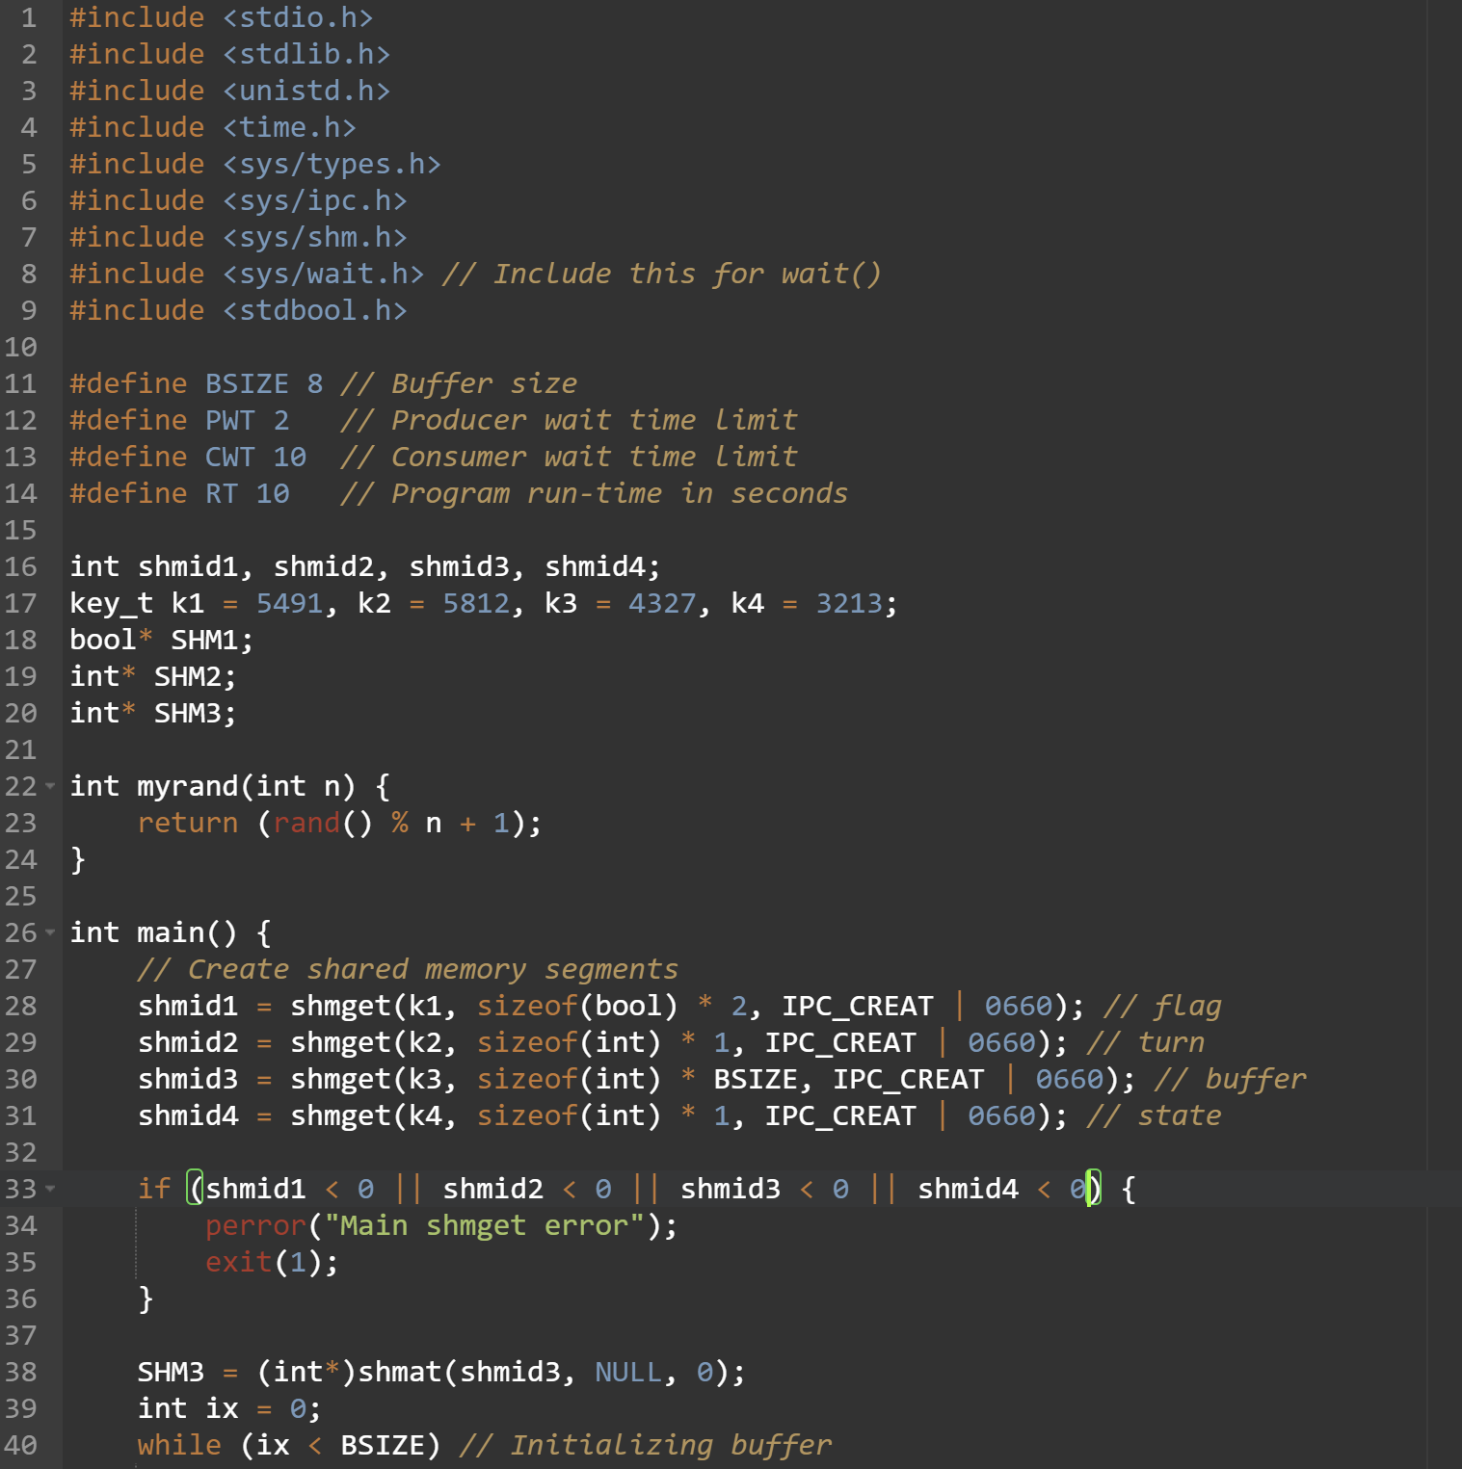

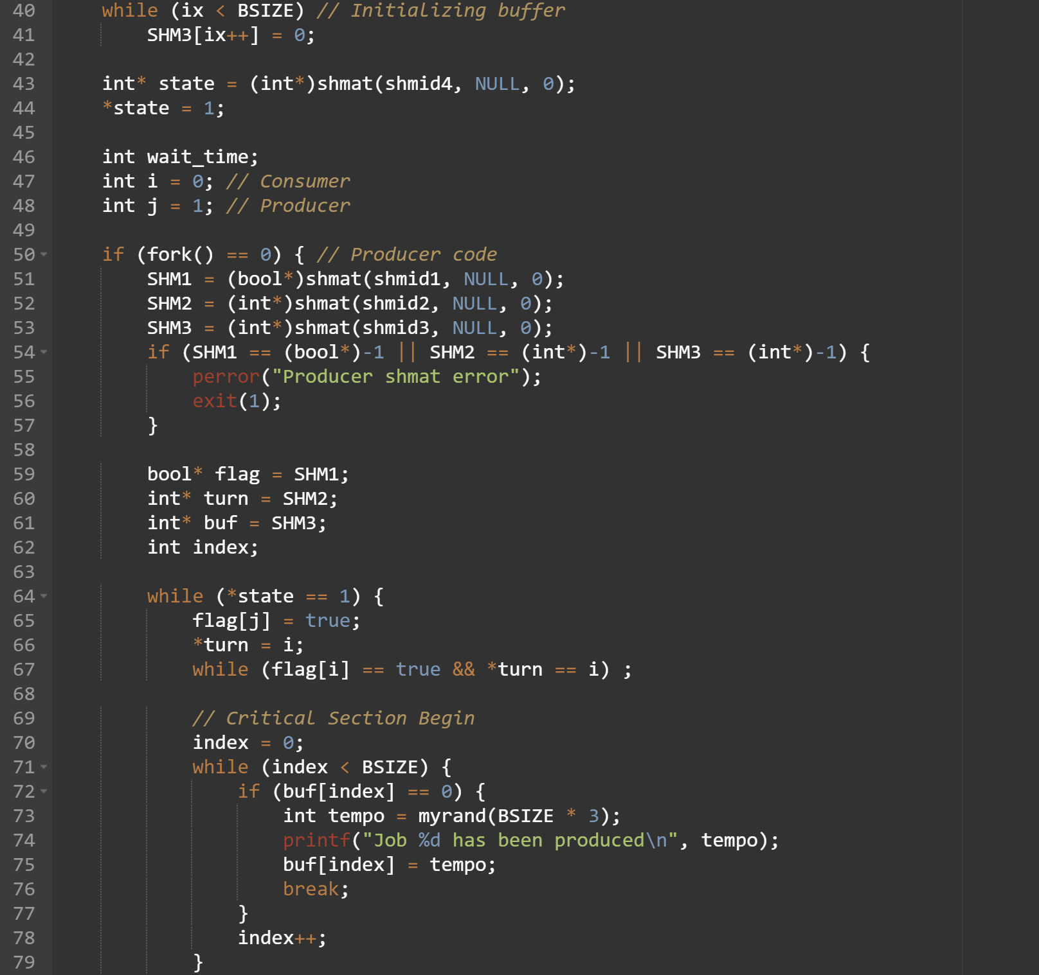

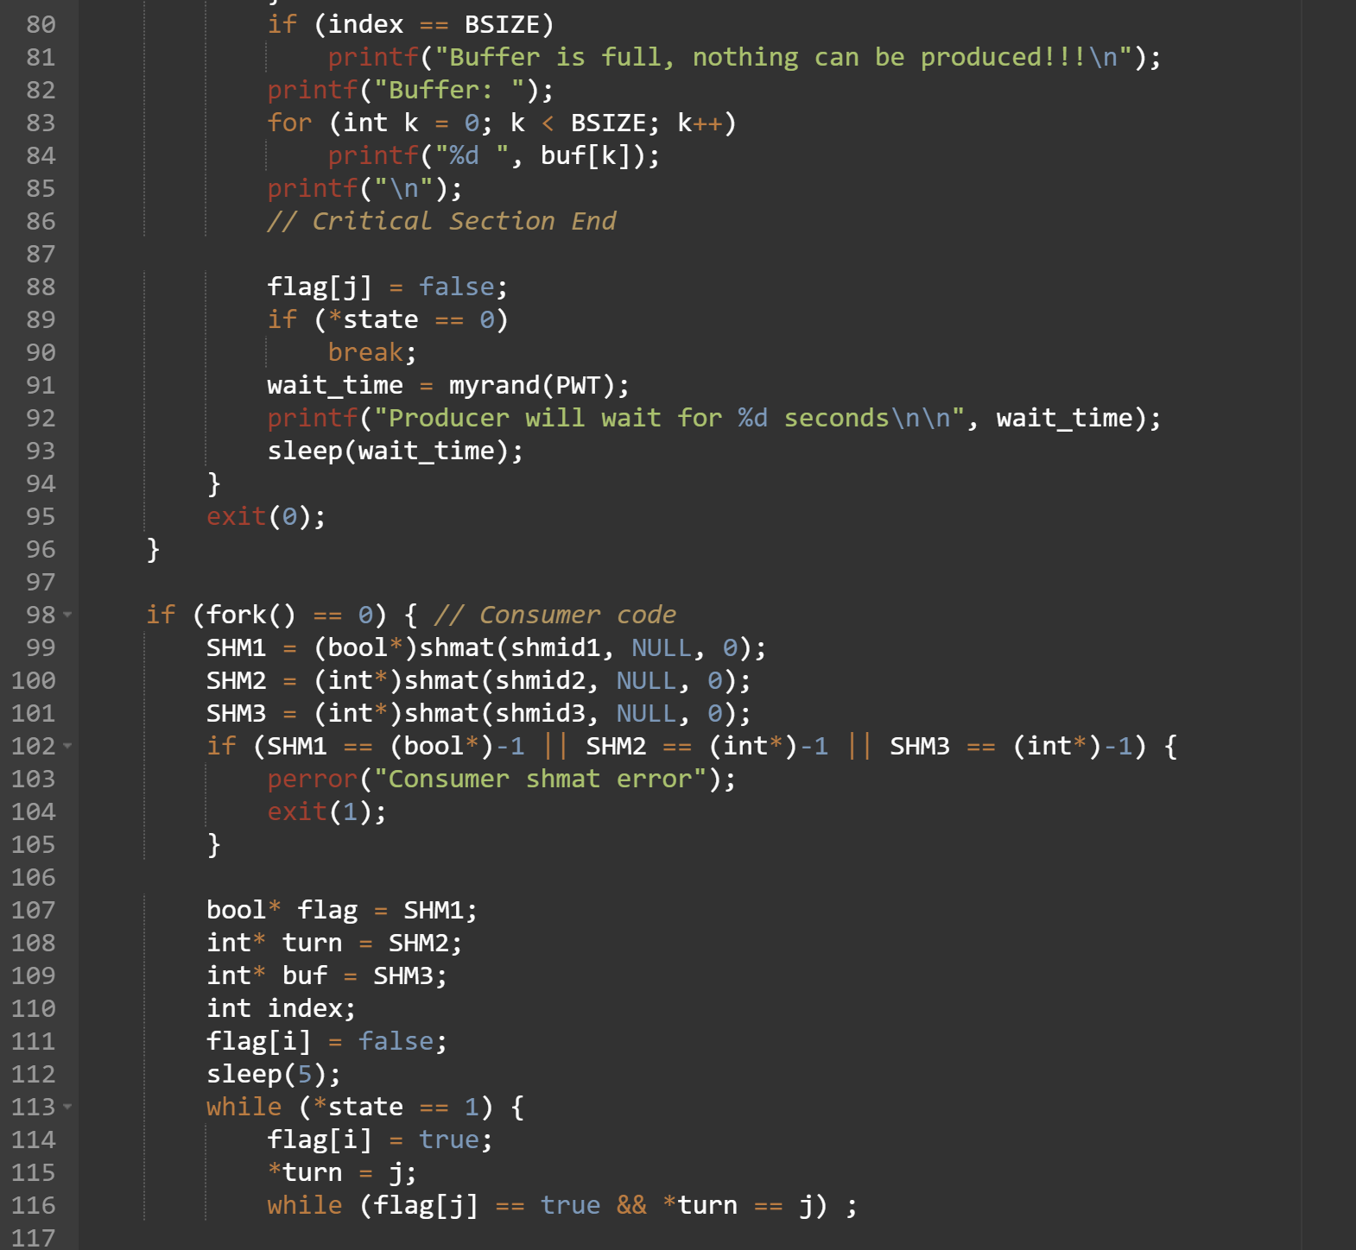

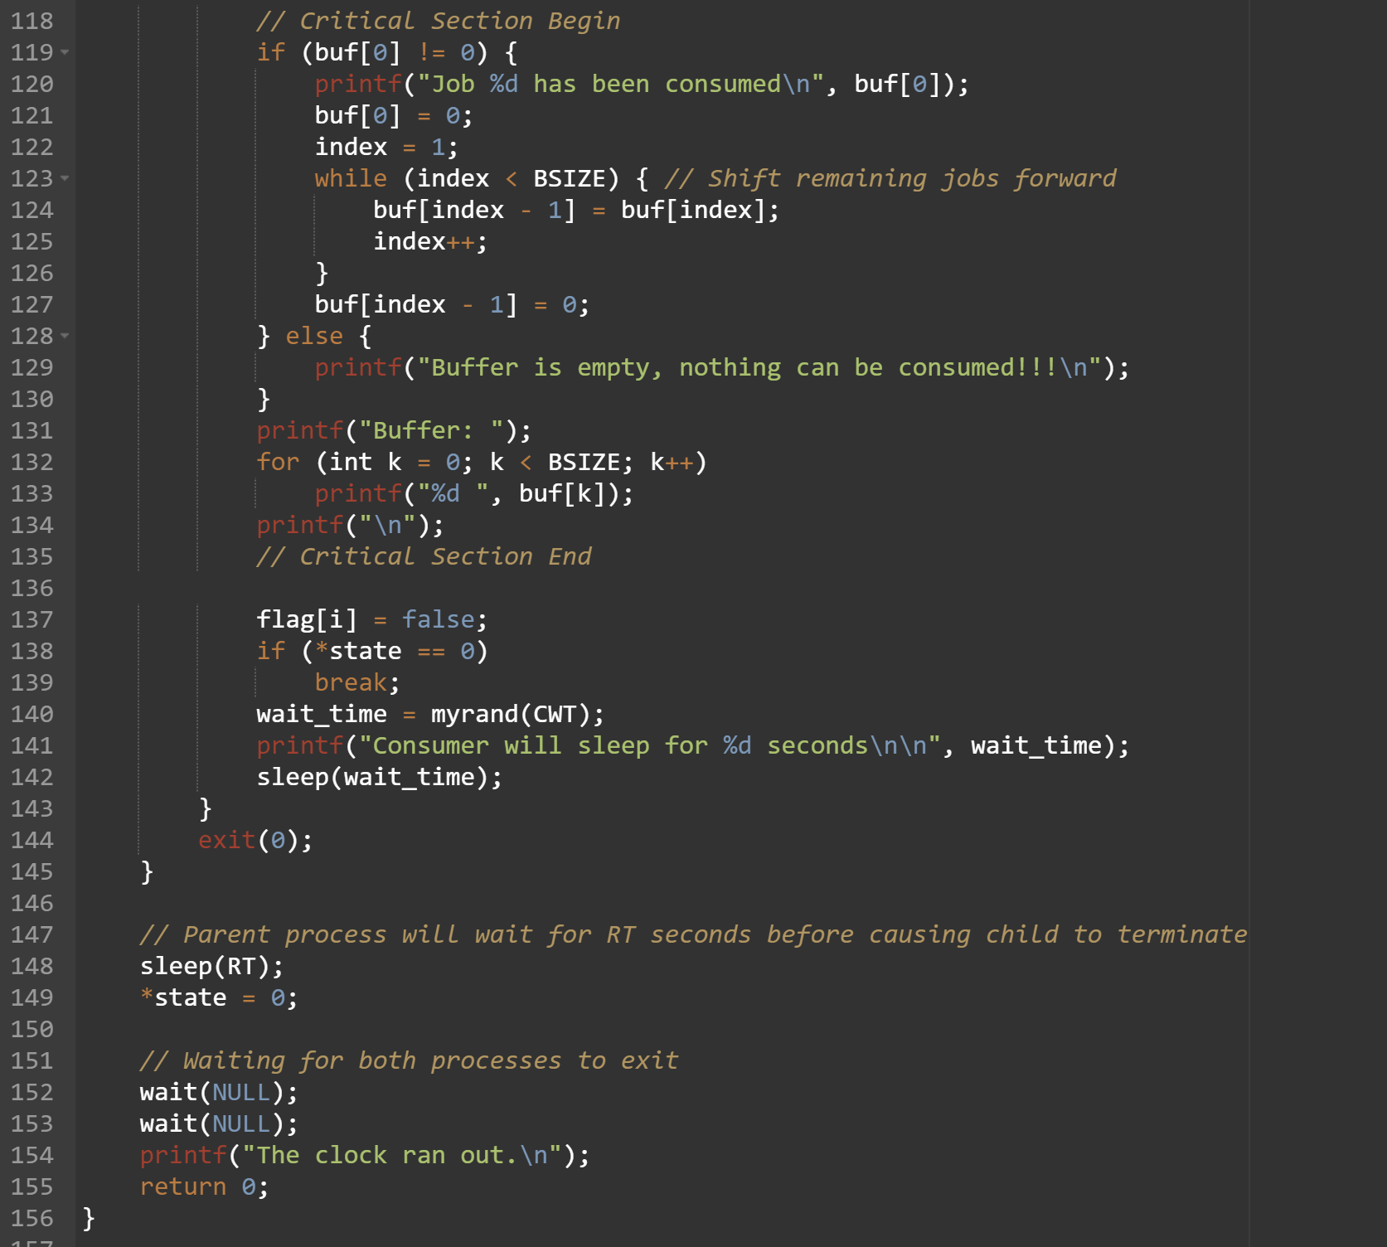

**Output:**

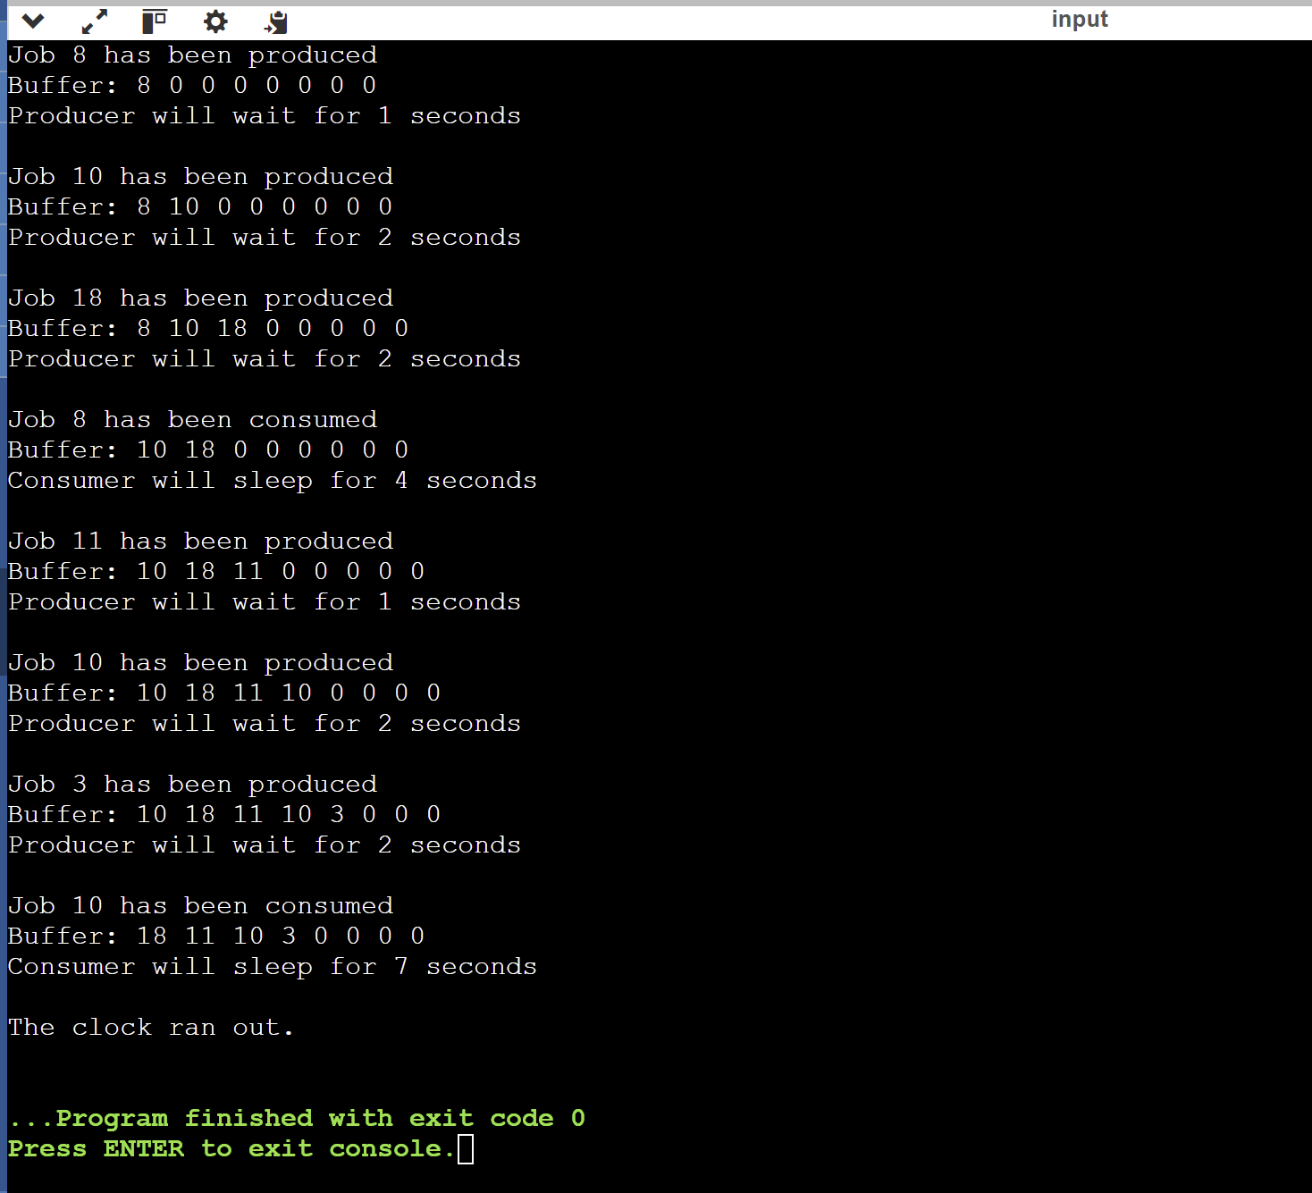

**2)**

**Critical Section Solution:**

#include <stdio.h>

#include <stdlib.h>

#include <pthread.h>

#include <unistd.h>

#define NUM_THREADS 5

// Global variable to be accessed in the critical section

int shared_resource = 0;

// Mutex for protecting the critical section

pthread_mutex_t mutex;

// Entry section

void enter_critical_section() {

pthread_mutex_lock(&mutex);

}

// Critical section

void access_critical_section(int thread_id) {

printf("Thread %d is entering the critical section.\n", thread_id);

// Simulate some work in the critical section

int temp = shared_resource;

sleep(1); // Simulate time-consuming task

shared_resource = temp + 1;

printf("Thread %d has updated shared_resource to %d.\n", thread_id, shared_resource);

}

// Exit section

void exit_critical_section() {

pthread_mutex_unlock(&mutex);

}

void* thread_function(void* arg) {

int thread_id = *((int*)arg);

// Entry section

enter_critical_section();

// Critical section

access_critical_section(thread_id);

// Exit section

exit_critical_section();

return NULL;

}

int main() {

pthread_t threads[NUM_THREADS];

int thread_ids[NUM_THREADS];

// Initialize the mutex

pthread_mutex_init(&mutex, NULL);

// Create threads

for (int i = 0; i < NUM_THREADS; i++) {

thread_ids[i] = i;

pthread_create(&threads[i], NULL, thread_function, &thread_ids[i]);

}

// Join threads

for (int i = 0; i < NUM_THREADS; i++) {

pthread_join(threads[i], NULL);

}

pthread_mutex_destroy(&mutex);

printf("Final value of shared_resource: %d\n", shared_resource);

return 0;

}

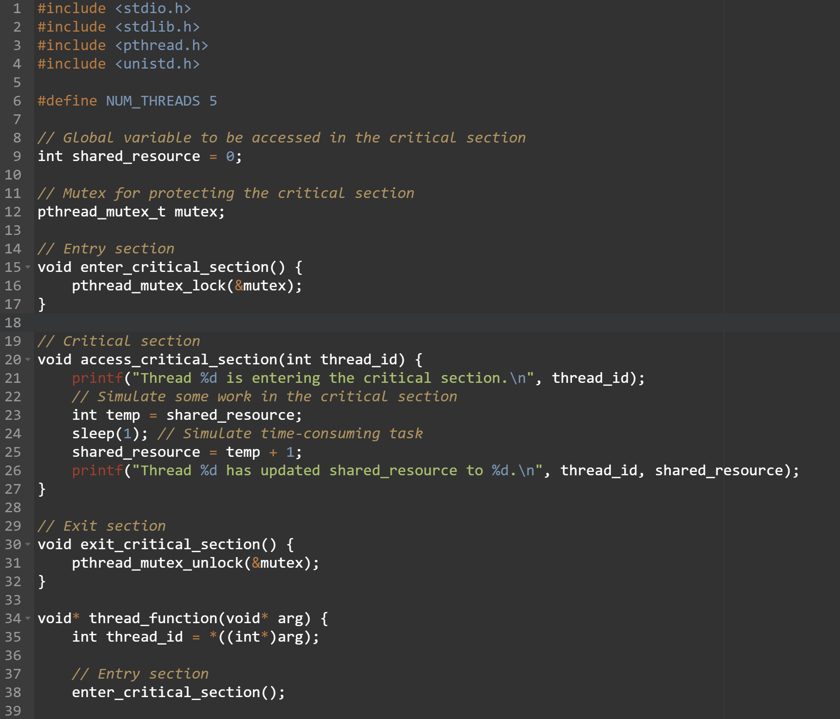

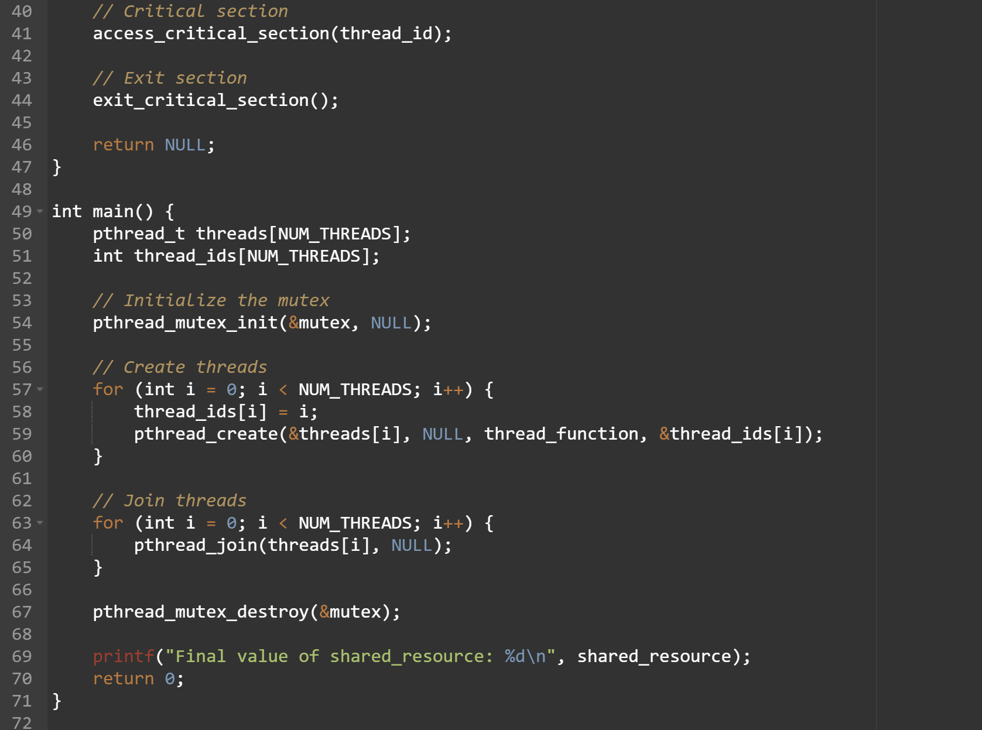

**Output:**

